Rural Edufiy
Abstract:
The project is made for improving the efficiency and performance of the attendance system for the rural schools as they are prone to make fake proxies and errors. Many times people mark proxy for another person and take a meal in their name and no one is able to identify it , so keeping this in mind I have created a web-based automated attendance system to enhance the technique of taking attendance. The system uses frontend user-interface, backend processing, storage in database to manage data of the data efficiently. It solves all the problems in real time and is transparent and secure to any threat. Also enhances the productivity of the attendance system in the rural schools.
Background:
As you know the normal way of taking attendance in rural schools are either manual counting or registering the student on basis of their name and then every time taking attendance on the basis of the registered name. Because of this it is way more complicated to store the data as it can be altered or changed by anyone without any permission. Also there is a high chance of doing errors. On making the automated system, the chances of error reduces and the complexity of the system reduces. Even the storage problem is reduced as it can easily be stored in the database. In traditional ways the tracking of any student attendance and performance was very tough as you had to find everything manually and it was really time taking. Also, because of the data stored on registers they can be altered easily and there will be no track and no one will ever know about it. But in automated system , only admin can alter the data and no one else. Also, it is easy to track the performance of students and make a schedule of extra classes whoever needs it. It was difficult to track mid day meals providence as people use fake identity to take more mid day meals, so the new system can also track it for you and easily specify the need of mid day meals. Any absent of teacher can be compensated easily with the free available teachers .
Proposed System:
The system is a platform for the rural schools management system which can make the complicated things less complicated and time taking things less time consuming. It is designed while keeping in mind the scenarios that are their in the rural schools. The system make it easy to store the data at one place and is accessible easily any time and any where. The error which can occur on manual basis is fixed and the technology is made advanced to make the process faster. The main feature which distinguish it from the available existing systems is the affordability of the system. The main focus is for rural areas schools as it also tracks the mid day meals for the students , with a emergency reach out to provide the emergency easily at any time. Only the admin can make any changes in the following system and no one else which makes it secure and more trustworthy from other sources. Unlike other large and complex systems , it requires less internet speed which shows it is specially designed for the rural areas as there the internet connection is very less .It avoids unnecessary features which are not needed for a rural schools, making it easy to understand and use for rural people also. The working of the proposed system is simpler as it is made keeping rural people in mind as they are not much of a tech freak like modern urban peoples , so the design is as follows:

- Firstly the login credentials are required to login into the platform and it can only be logged in by admin as only it has the authority
- Then, you can see a dashboard with certain information about schools students like total student, strength of students for today, absentees for today and any emergencies or not
- There is also a quick action section which can take you to the certain page like add student, broadcast notice, approve leave , view meal tracking
- Attendance section where you can check for attendance for all students from each class and their overall attendance percentage and give a notice to the parents if the attendance percentage is less than 75 percent
- Then, there is a student section where admin can add or see the data of any students he wants
- There is a Staff duties section where admin can see the data related to teachers and their free timings, it helps in assigning the duties when any teacher is not available for certain timing
- A emergency section, when any emergency related to heath or any other issues is generated it is broadcasted and the action which is required is taken , then it is marked resolved
- Then the most important part for a rural schools which is mid day meal tracking , it tracks the mid day meal provided to the students attended today and generates a report which is then stored in the database
- Parent communication section for the notice section, while previously they used to make a printed note and handle it to every student, now they don’t have to do that and everything is directly sended as a notice to the parents
- Then there is a performance tracker that tracks the performance of every student and every class , if a student is having less than average marks in any subject then they has been assigned a extra class on the particular subject
- Then, a setting section where you can log out when the work needed to be performed is done
System Architecture:
The system follows a basic layer architecture which has main three layers, they all work together for creating the system working and ensure that it is working smoothly and there is no errors in the running of the system. It makes sure that the system is efficient, runs coordinately and is easy to use. The following three layers are:
- Front-end layer: It is the front layer which is the interface that user sees and interacts with and the designs in this layer is created by react.js because it gives us a clean and simple user friendly look, so user find it easy to use and interact with. It displays all the data or result within the table and user can naviagate through pages from one page to another and there are different view and designs on each page. It is just a face which shows the work or stored result and help the system to look user friendly.
- Backend layer: It is built using Node.js and Express.js. This is the logic layer like is is the connection between the frontend and storage layer. It performs actions like marking attendance system or tracking the mid day meals like how many present students got the meal and how many are still left, tracks the performance of each students. It uses the values stored in the database and then calculates things like average of the class then compare it to the particular student and displays the things on the front end page. Similarly in case of the attendance system uses the attendance record to calculate the percentage of classes attended by each particular student and if any student is not attending classes and has attendance percentage less than 75 percent then a message is sent to that student parents.
- Storage layer: It is the database layer whose function is to store all the values like attendance of each day , mid day meal , students and faculty information , the performance of all the students. It also ensures the security of the database and the system so that every thing is secure and there is transparency in the system. Also no one aside from the admin is allowed to change or alter any information in the database or the system.
By combining these the overall working of the system is smooth and data security is managed.
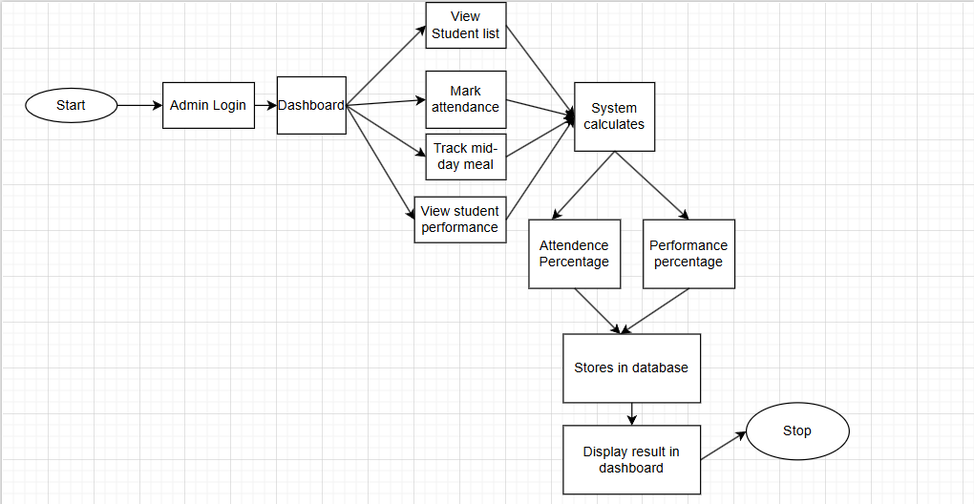
Protocol Stack:
In the following system the protocol stack is defined as how the data is transferred between user and the system. By combining all the stacks the reliability of the system is ensured and the communication between user and system increases with increase in efficiency and security between both of them.
The system uses these following layers to ensure the working environment of the system:
- Interaction layer: This is the layer where the user is interacting with the system. Every activity such as the selection of any particular section on the user interface, any request of data from the database or anything related to search for the information about the data is happening in this layer and it send a request to the processing layer to process the information required by the user and then displays the result which It receives from that layer to the user. Its main function is to make the environment user friendly and see that there are no complex structures that the user cannot understand. It uses methods like GET, PUT, DELETE using HTTPS protocols to ensure the security of the system and integrity of the system.
- Processing layer: In this layer, the processing of the data happens. The request which is given by the Interaction layer about the need of the user is processed here and the solution is founded out. Like it converts the need of user into the command the database can understand or as it is known that every part understands the data differently, so it makes them understand every thing by processing the data in their terms of understanding. It also manages the security of the sensitive data with the help of HTTPS protocols.
- Transport layer: This layer focuses mainly on the communication part between the system layers. It ensures that the communication between the layer is smooth and correct. Checks for the errors which happen between the communication of two layer like loss of any information which is important and the function might not be able to give the proper details if there is not complete information. This layer uses TCP(Transmission Control Protocol) to ensure the communication is reliable and smooth.
- Network layer: This layer handles the transmission of the data from one destination to another destination. It makes sure that the network between the destination and the source is established correctly to make the flow of data correct. It involves things like using of LAN , wifi or any routers etc.
Together these layer make sure that the system is working fine and there is no disturbance between the user and system interaction also there is no error inside system such as the communication and network inside the layers itself is working fine.
Testbed / Experimental Setup:
For the testing of the system after completion about its performance and reliability of the system, I have created a environment which can be used in evaluating the system. There are some hardware and software used and the overall outcome is generated .
- Hardware- I have ran the project in a good processing computer so see the outcome of the system and also on many other different devices to see if the interface is adjusting itself or not in different devices. The system was working more than fine on all of the devices and there was no error in any part of the platform in the system and the working was smooth and the interface was user friendly.
- Software- React was used for the development of frontend and Node and Express was used for the development of backend. We ensured the correct flow of the data information and security by attacking it and trying to alter the records from a account which is not admin and it didn’t allow any changes other than admin permission.
- Data Test- For the testing of data, I have created a realistic dataset of 7 classes with each class having 3 sections and in each section the students strength varies from 33 to 40. The attendance of each student for one whole month is recorded and there percentage is calculated by the system itself and all those calculations where perfect and no error was found out. For the performance tracking I have used the results of there marks in each subject and if there is any one who has less marks than class average in any subject they have been assigned a extra class for that particular subject and the teacher with free slot during that time is assigned to the extra class. For the emergencies the data is perfectly fine.
This has helped in testing the system efficiency and its working in a real life environment which shows that the system is working fine and will be of great use.
100 % implementation:
The model is completed and working fine and is fully functional with many function which are made specially for the rural areas schools so the screen shots for the following things are:

Login page:
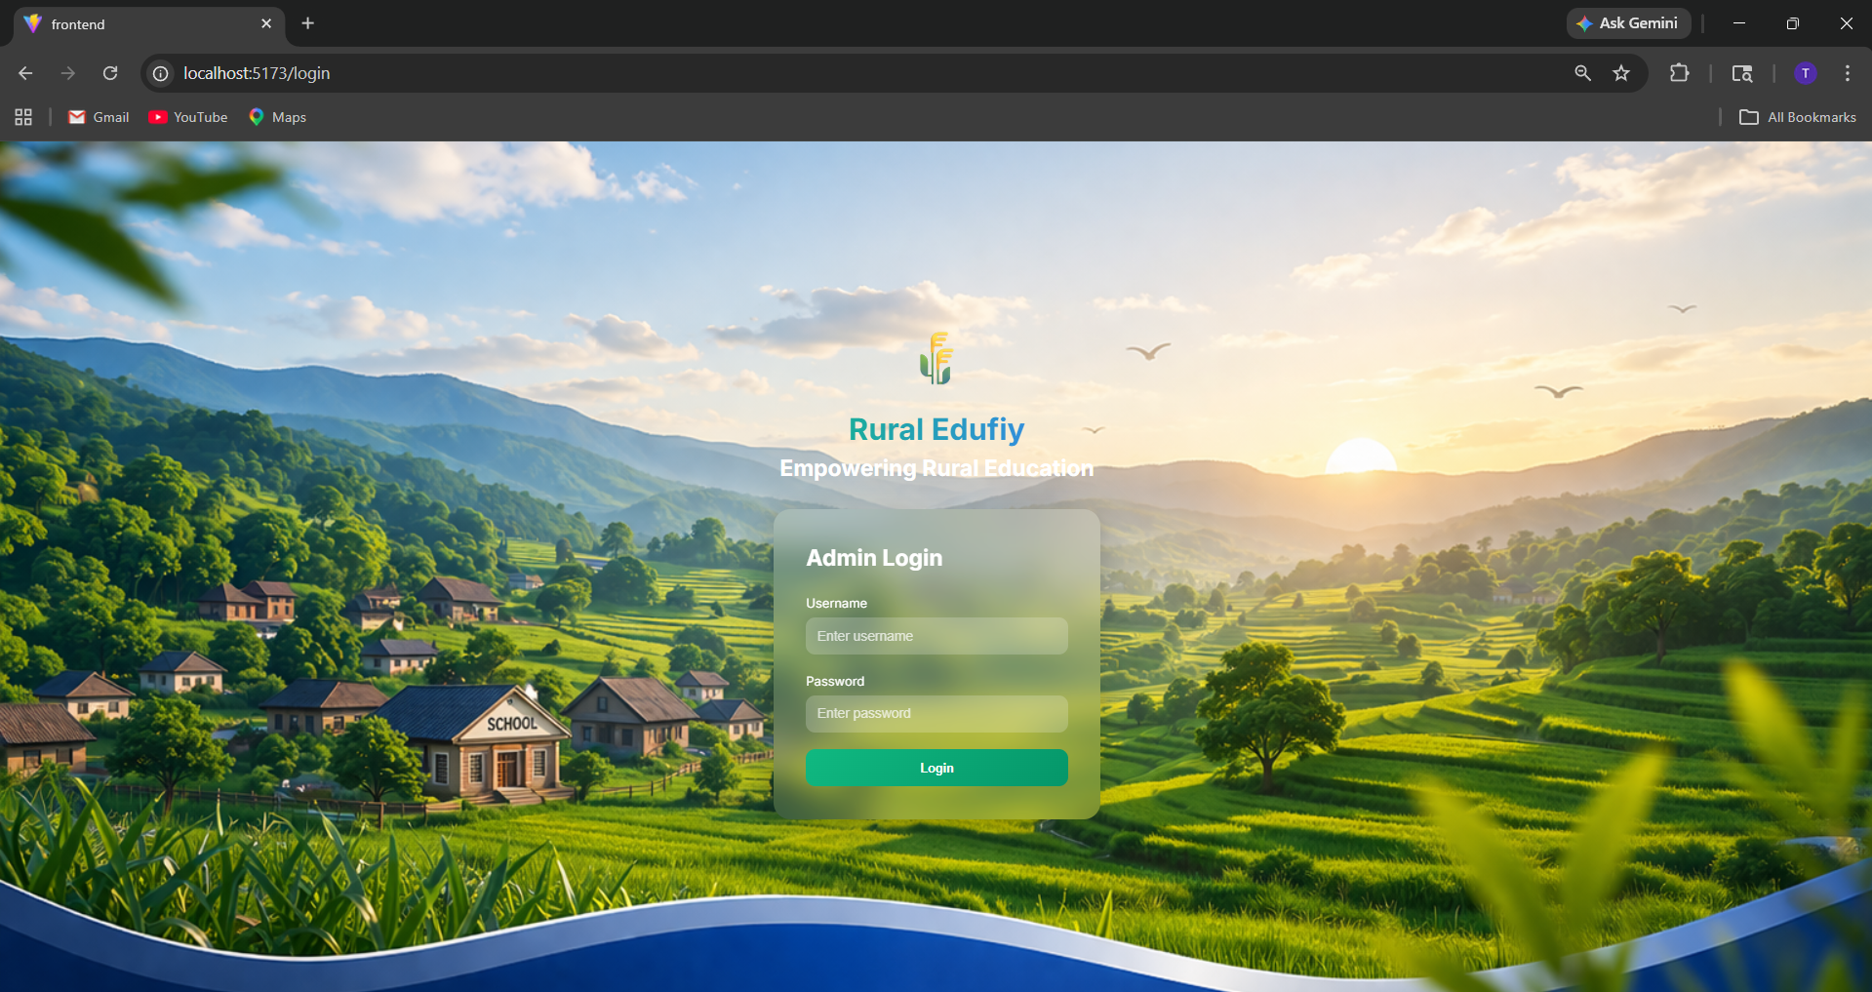
This page basically checks for the authentication of the user and only allows admin to let in , making the system secure and trust worthy.
Dashboard:
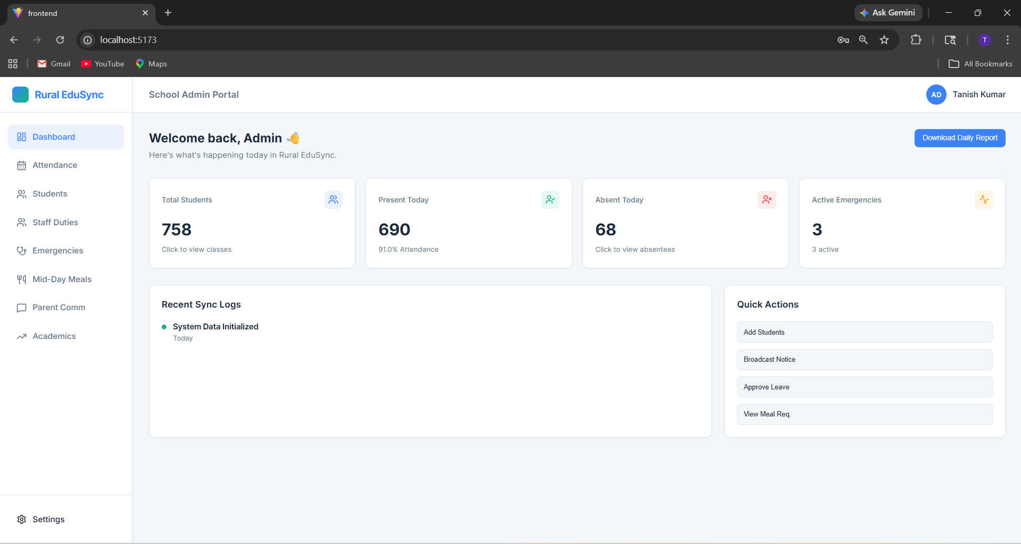
It shows the data of the school like total student, present today, absent today, any emergencies and has the section to take you to the page where you can perform actions like add students, Broadcast any information, take leave and view mid day meal. After clicking on total students you can see the information of the classes
Classes Overview:
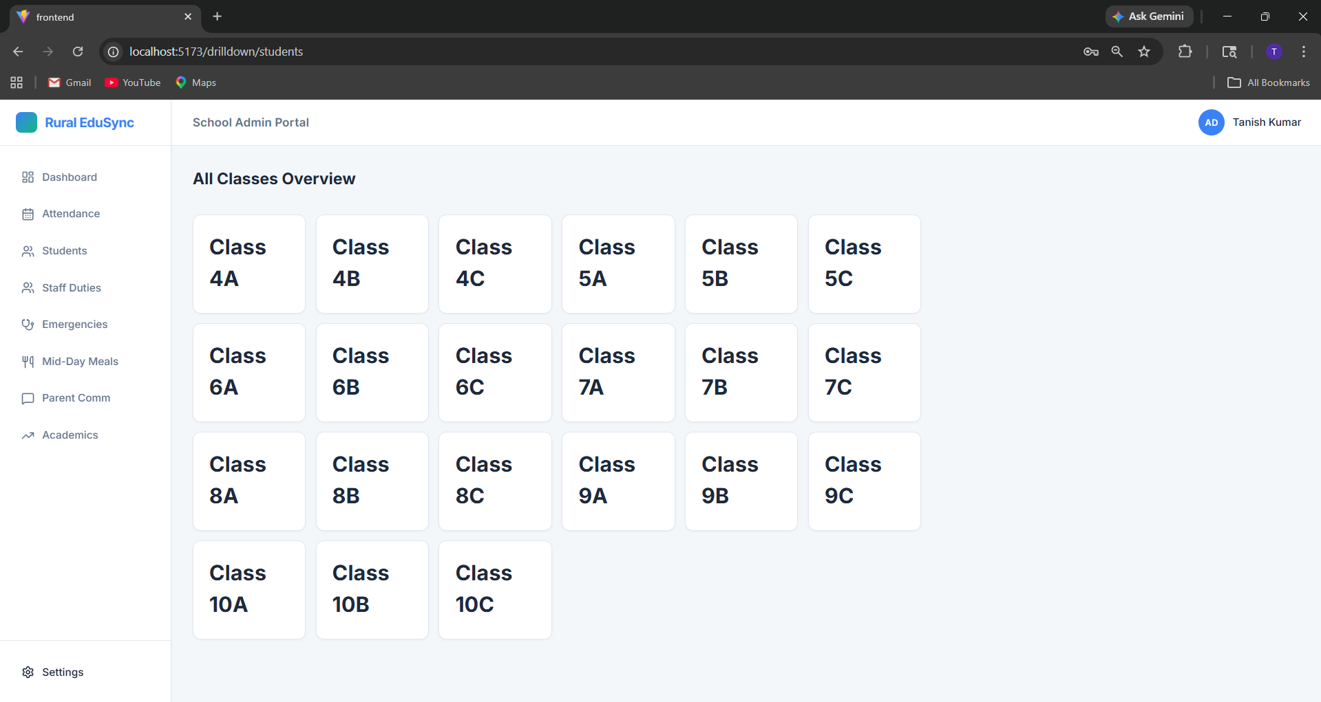
After clicking on any particular class you can see the information about that particular class and students in it
Particular class information:
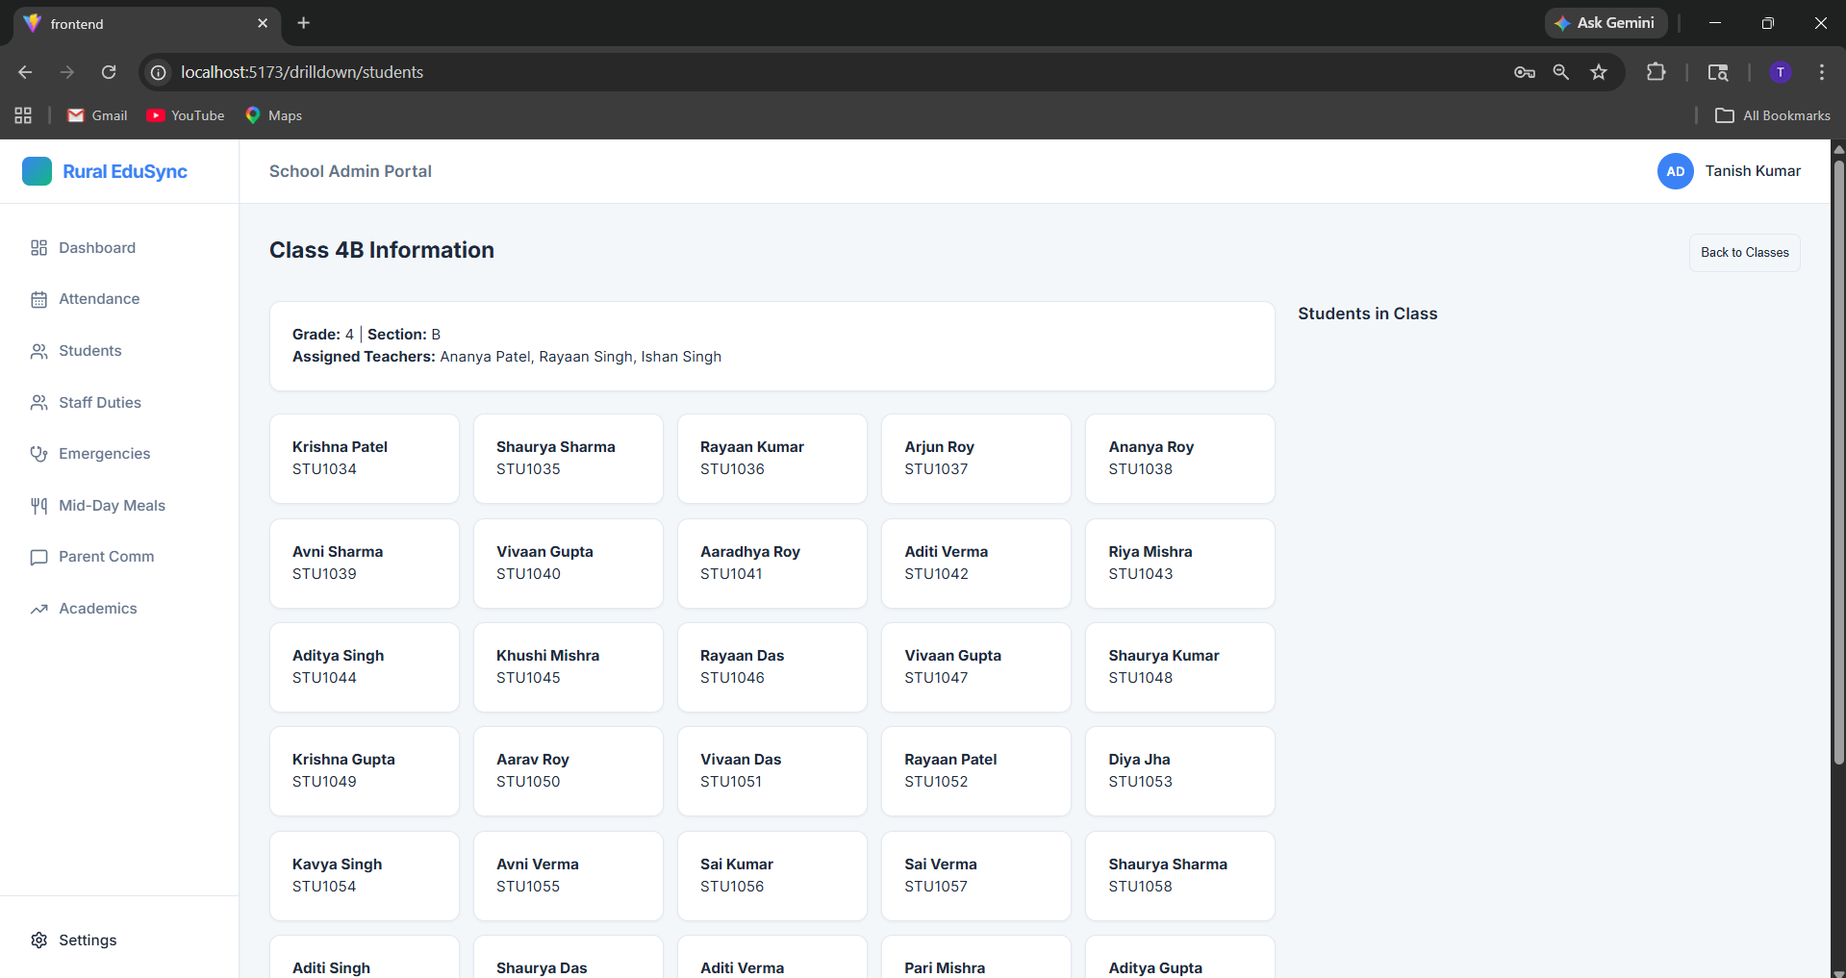
This section shows the details of the students grouped through a particular class and you can see their information like their address , parents number, date of joining and etc after selecting a particular student.

Attendance of each class:
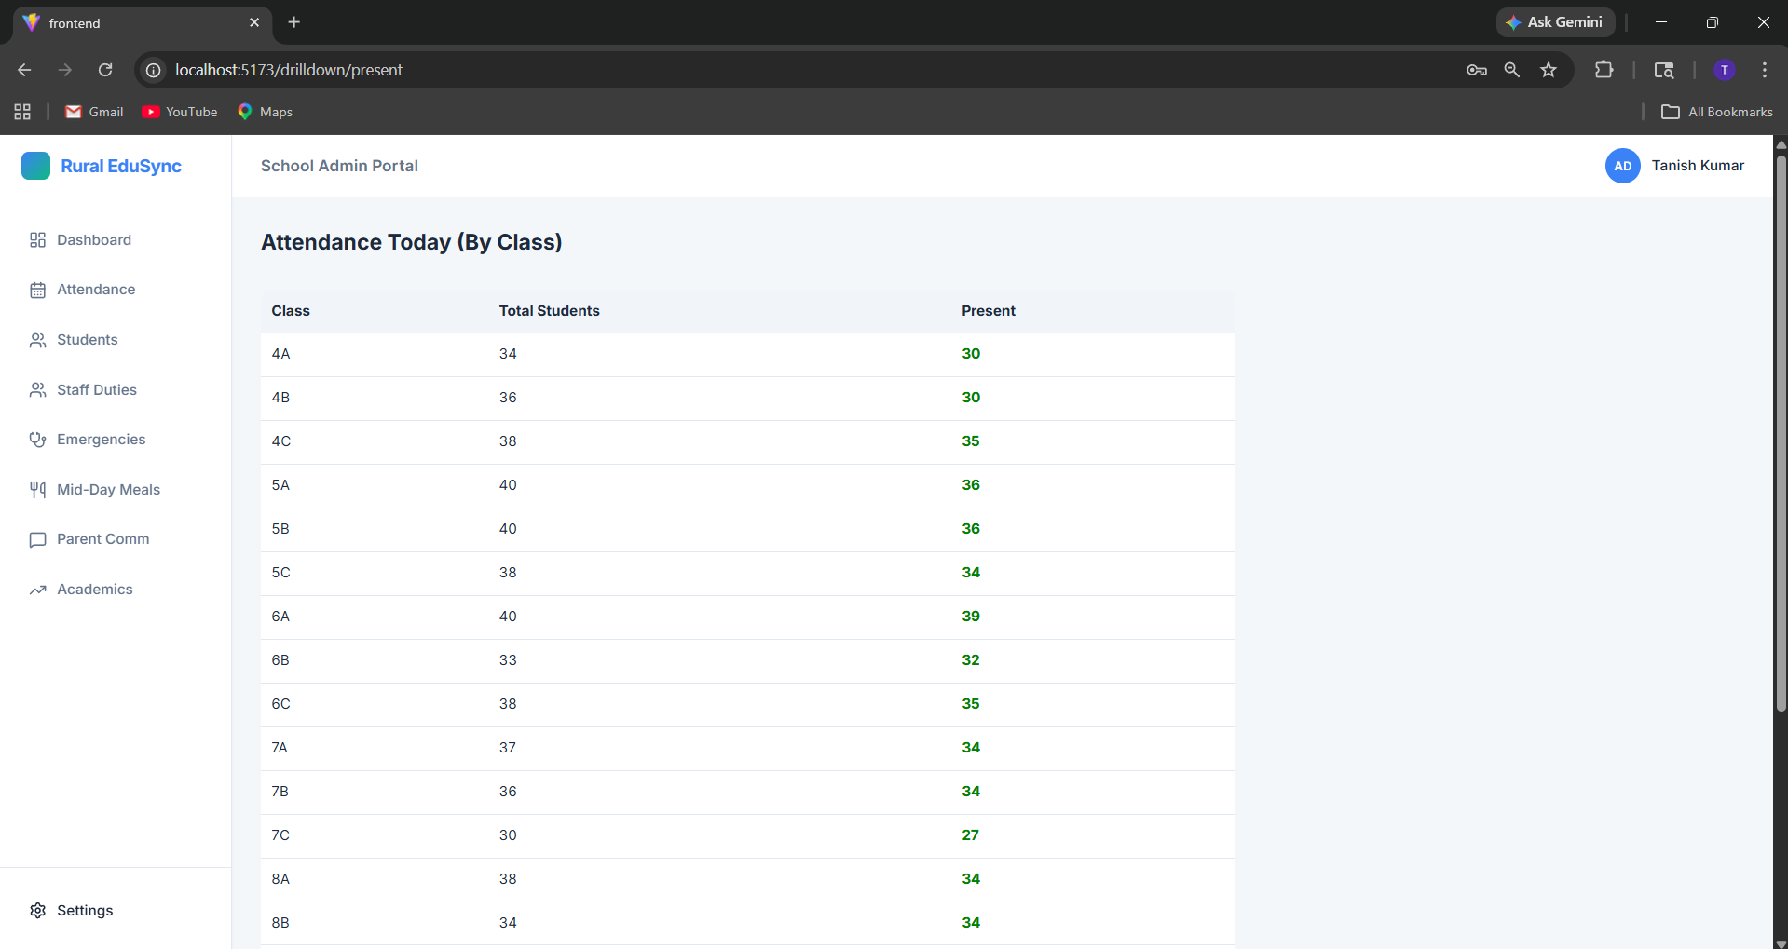
The Attendance of each class is displayed here and total students with total present today can be seen here

Attendance analysis and defaulters alert:
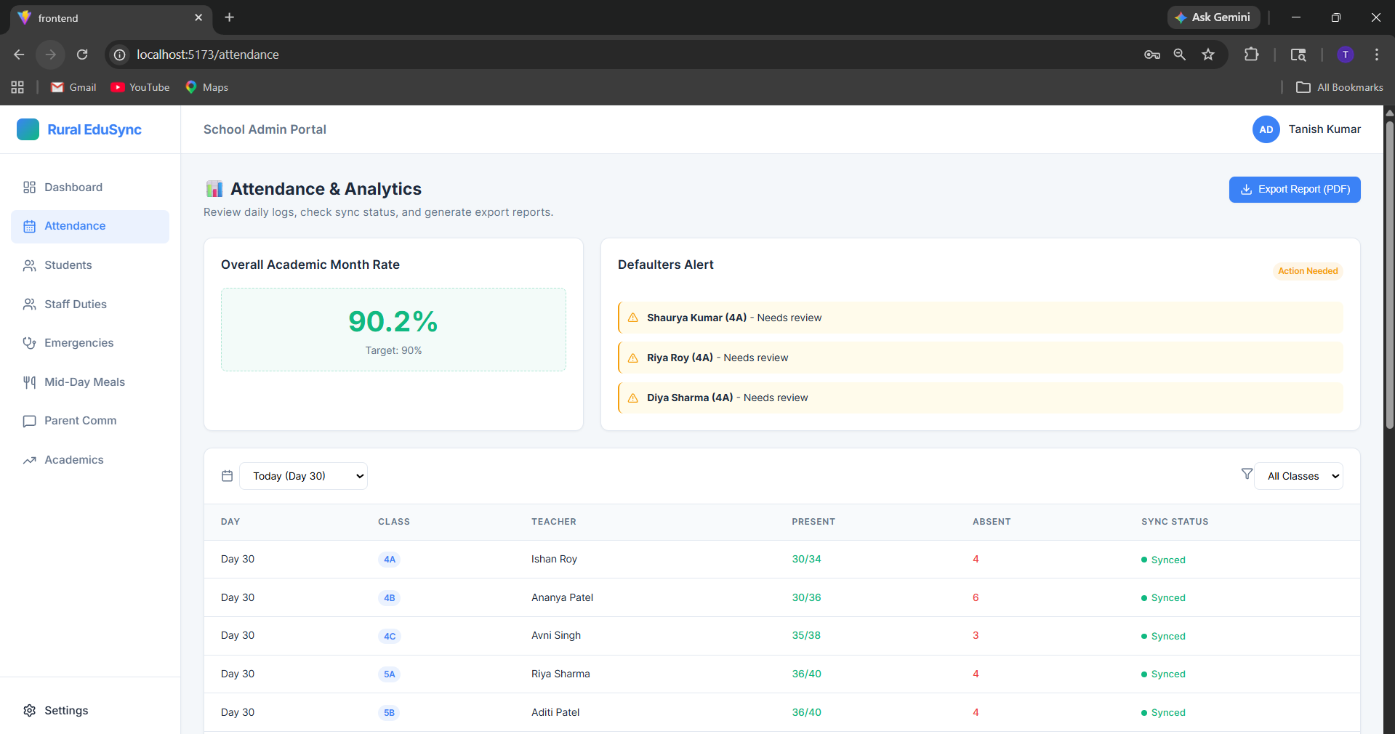
The attendance percentage is calculated here and the overall attendance of each student can be viewed with the defaulters who have less than 75 percent attendance and then also not attending class
Students section:
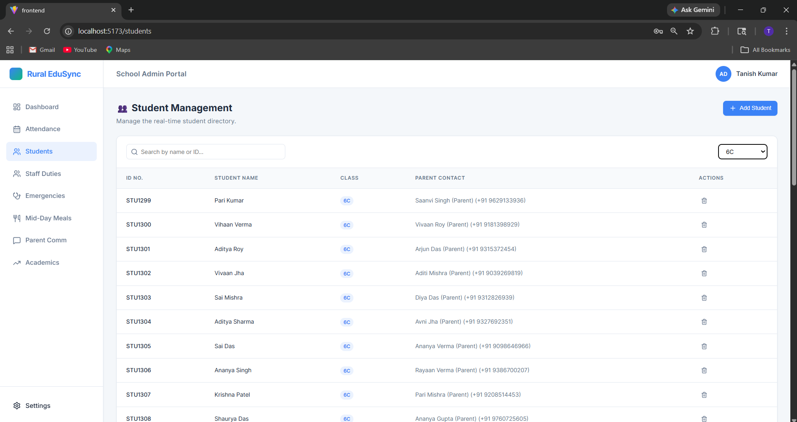
Here you can see the information about all the students and can see their parents number with there name. There is a filter which can help you find the particular student easily without any delay
Staff duties:
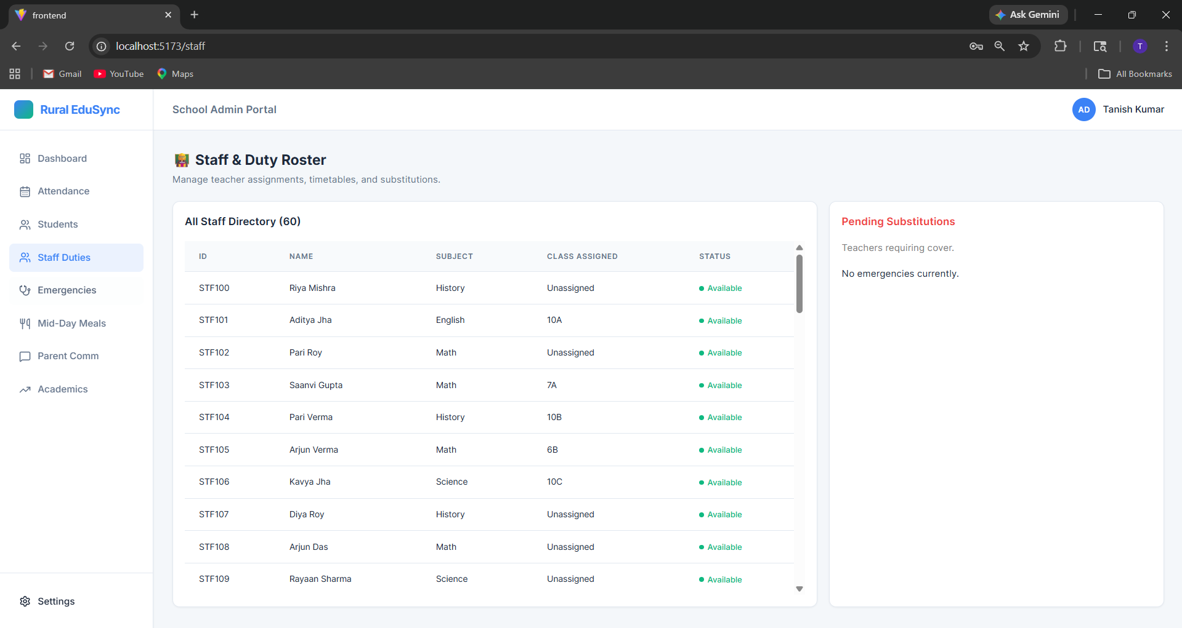
The substitutes and free timings of the teacher can be viewed here and if any teacher is absent it automatically assigns any other teacher who teaches the same subject to that classroom
Emergencies:
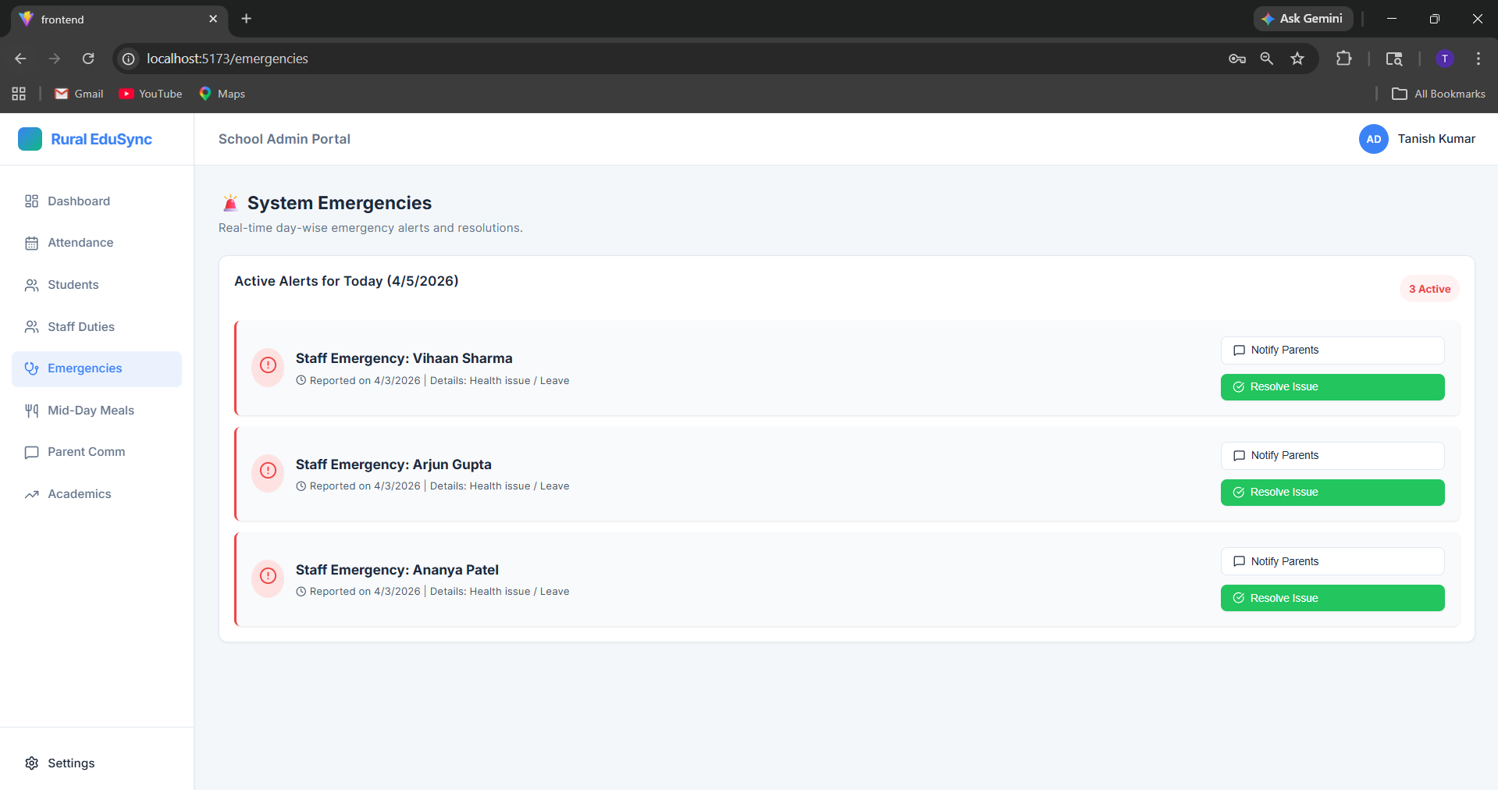
Any medical emergencies can be viewed here any it gives the access to notify parents directly through the webpage to their mobile number.

Mid day meal tracking:
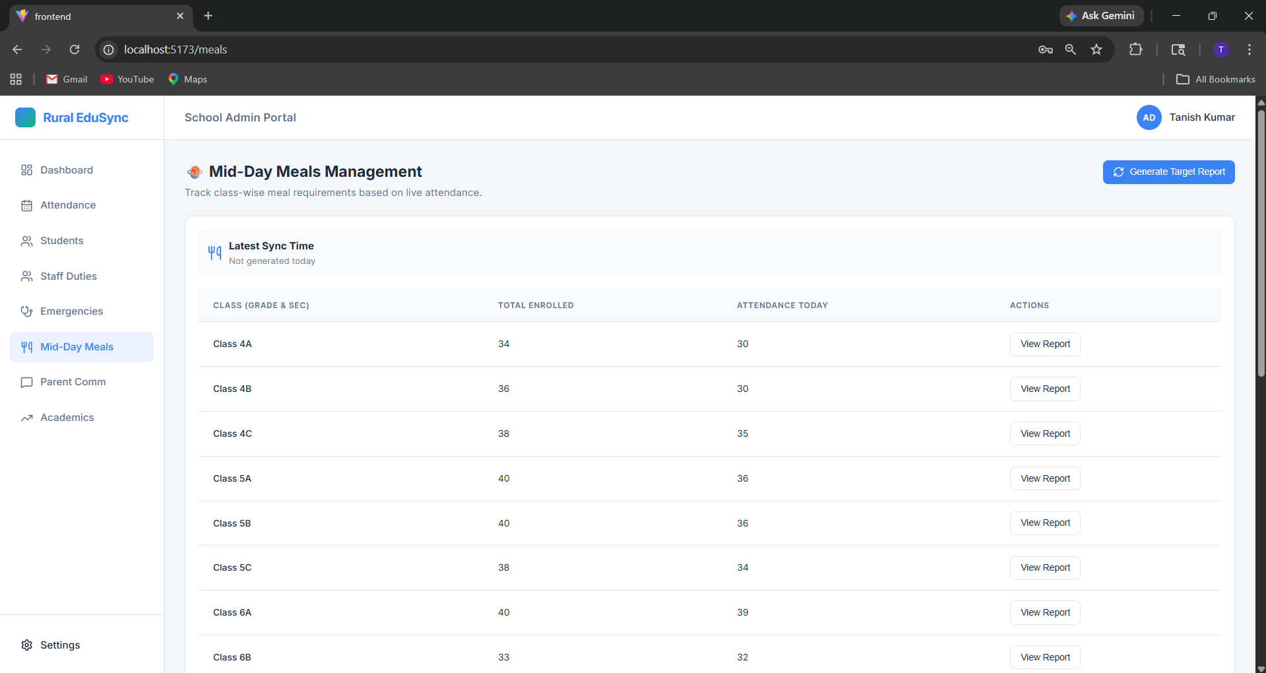
Tracks the mid-day meal like how many students are present and how many has received the meal and how many are still left
Parent communication / Broadcast section:
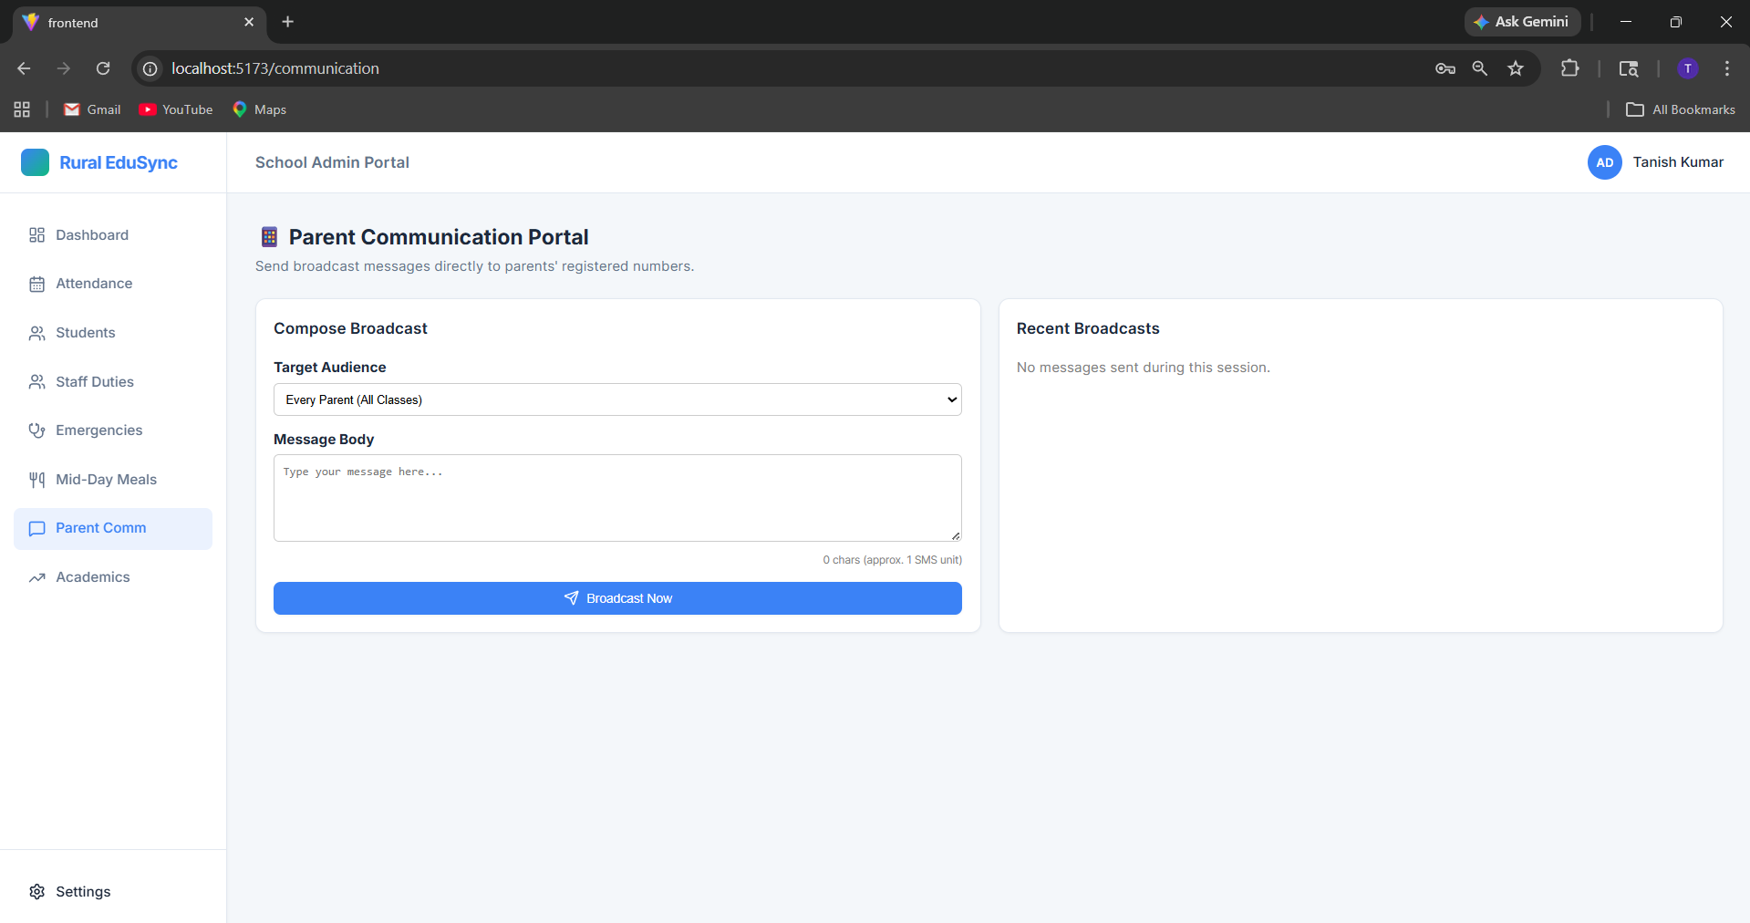
Any notifications to the parents can easily be generated from here and everyone will get the notification
Performance tracker:
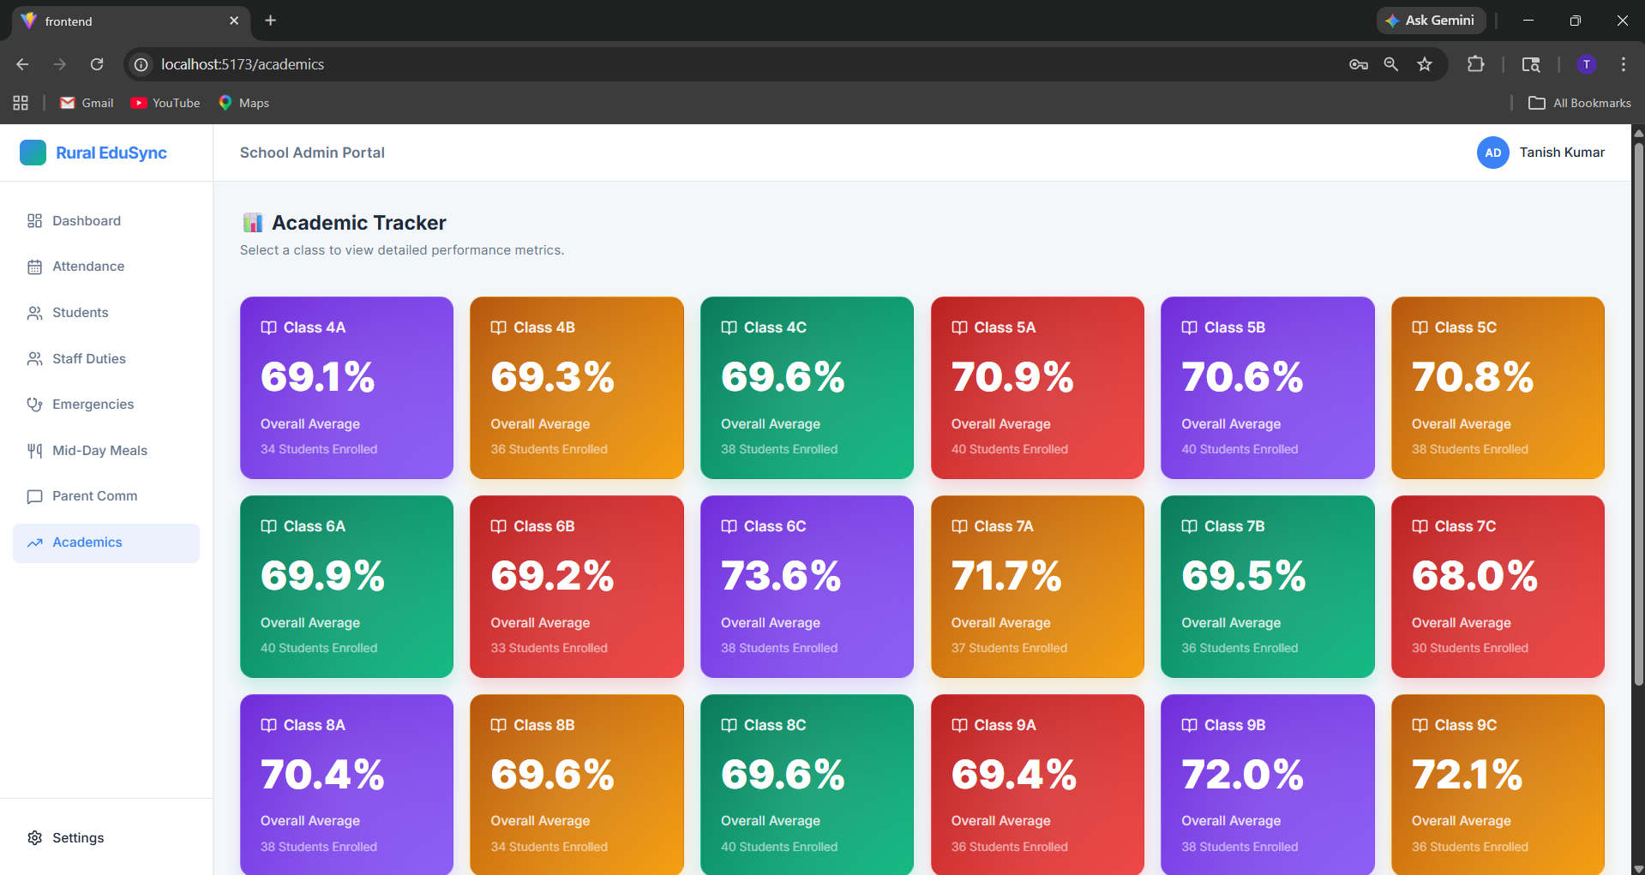
Tracks the performance of each class and calculate the average of the whole class
Academic report interface:
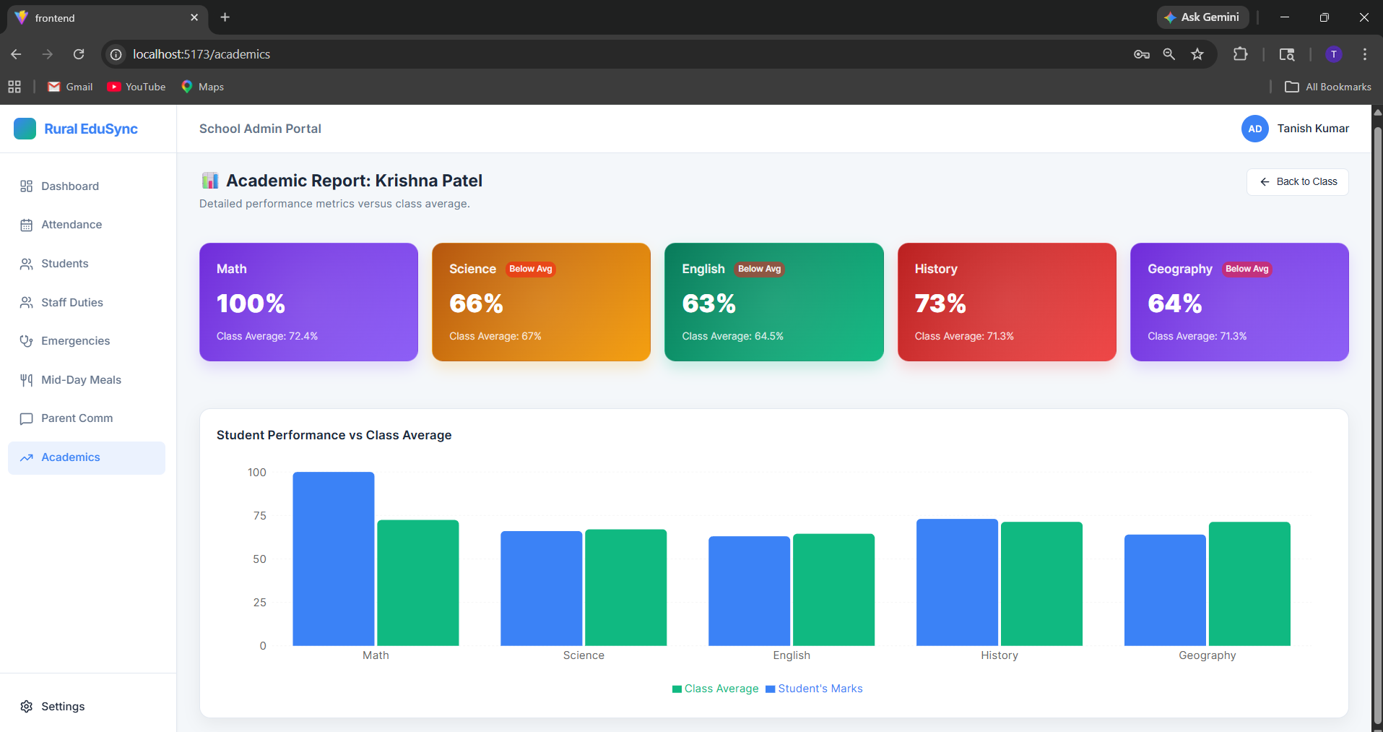
You can compare the performance of each student in the class with the class average and see the graph for better view understanding

